Hook

What is Hook?
# Source: AI Source: Provided by: [Data Path: Persons Table -> ID Column: 1, Name_En Column: Motasem Essam] -> From: [ChatGPT] on [2/15/2026]
A Git Hook is a script that Git automatically runs at certain points in the workflow.
- They allow you to automate tasks, enforce rules, or check code before or after specific Git actions.
- Hooks are local to a repository, but can also be shared in teams.

Key points
# Source: AI Source: Provided by: [Data Path: Persons Table -> ID Column: 1, Name_En Column: Motasem Essam] -> From: [ChatGPT] on [2/15/2026]
- What it does
  - Executes custom scripts before or after Git actions
  - Can prevent bad commits, run tests, or notify systems
- Location
  - Found in .git/hooks folder inside a repository
  - Hooks are disabled by default; you can create or edit scripts
- Languages
  - Written in shell, Python, Node.js, or any executable language

Common Git Hooks
# Source: AI Source: Provided by: [Data Path: Persons Table -> ID Column: 1, Name_En Column: Motasem Essam] -> From: [ChatGPT] on [2/15/2026]
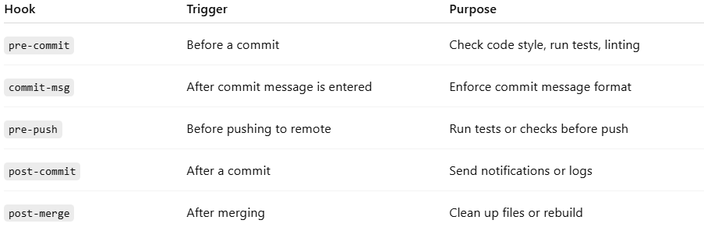
Hook | Trigger | Purpose
pre-commit | Before a commit | Check code style, run tests, linting
commit-msg | After commit message is entered | Enforce commit message format
pre-push | Before pushing to remote | Run tests or checks before push
post-commit | After a commit | Send notifications or logs
post-merge | After merging | Clean up files or rebuild

Example: Pre-commit Hook
# Source: AI Source: Provided by: [Data Path: Persons Table -> ID Column: 1, Name_En Column: Motasem Essam] -> From: [ChatGPT] on [2/15/2026]
- Create a file .git/hooks/pre-commit
- Add script (example: prevent commits with TODO in code):
#!/bin/sh
if grep -r "TODO" .; then
echo "Remove TODOs before committing!"
exit 1
fi
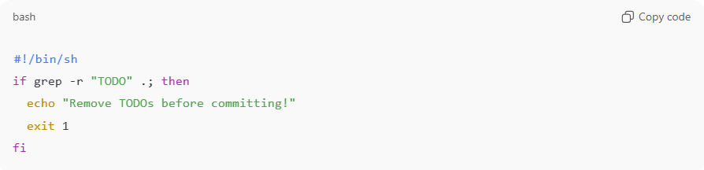
- Make it executable:
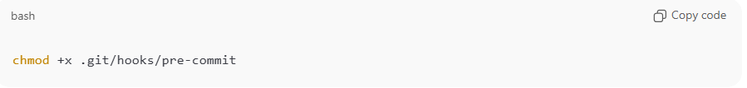
chmod +x .git/hooks/pre-commit
Now Git will stop any commit containing “TODO”.

Benefits of Hooks
# Source: AI Source: Provided by: [Data Path: Persons Table -> ID Column: 1, Name_En Column: Motasem Essam] -> From: [ChatGPT] on [2/15/2026]
- Automate repetitive tasks
- Enforce code standards
- Prevent errors from entering the repository
- Integrate with CI/CD pipelines

💡 Memory trick:
# Source: AI Source: Provided by: [Data Path: Persons Table -> ID Column: 1, Name_En Column: Motasem Essam] -> From: [ChatGPT] on [2/15/2026]
Hook = Git’s “trigger” → run your custom script automatically at certain points ✅

